

Task 3 of Semester Project

Submitted by:
Ayesha habib (sp24-bcs-034)
Adeen Fatima (sp24-bcs-039)
Ayesha Zulfiqar (sp24-bcs-029)
Submitted to:
Mam Mina
Subject:
Data Structures (Lab)

Project Name:

HealthCareHub – Hospital Management System

Task B: Testing & Output Verification
- PATIENT REGISTRATION – TEST CASES
✔ Normal Inputs
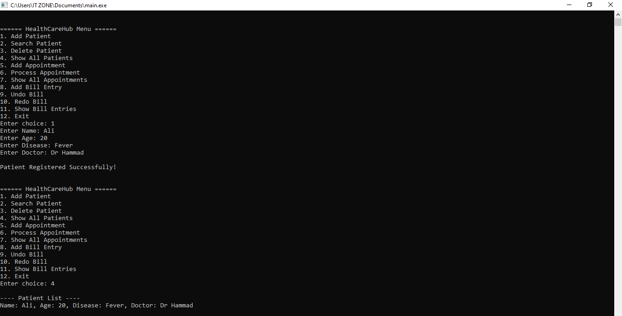
❌ Incorrect Inputs
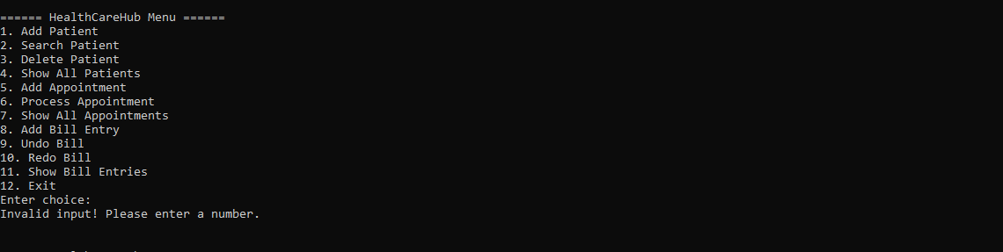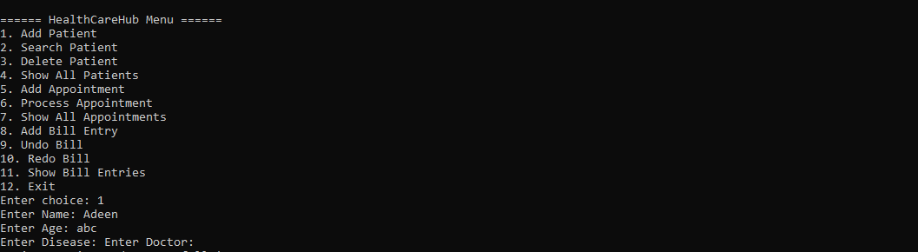

⚠ Edge Cases
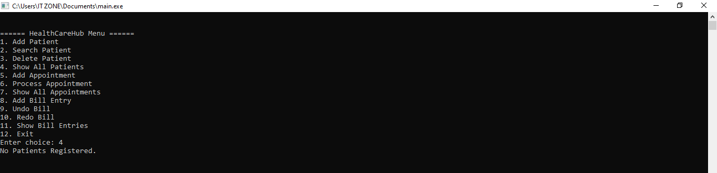
- APPOINTMENT QUEUE – TEST CASES
✔ Normal Inputs
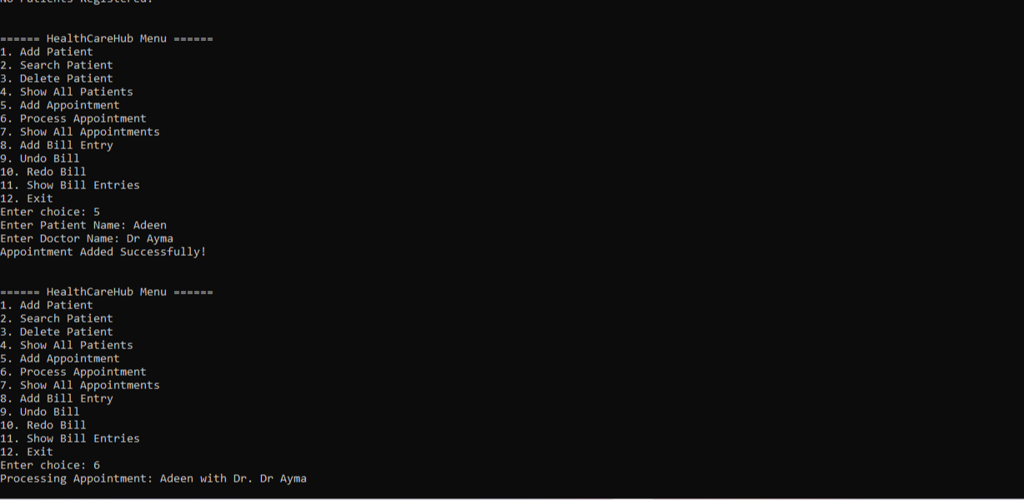
❌ Incorrect Inputs
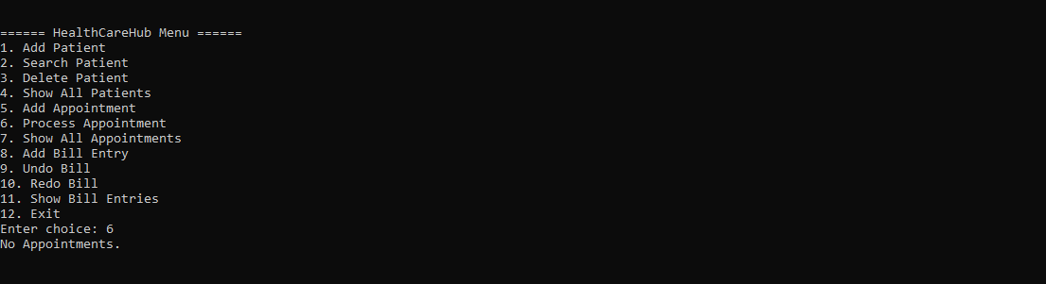

⚠ Edge Cases
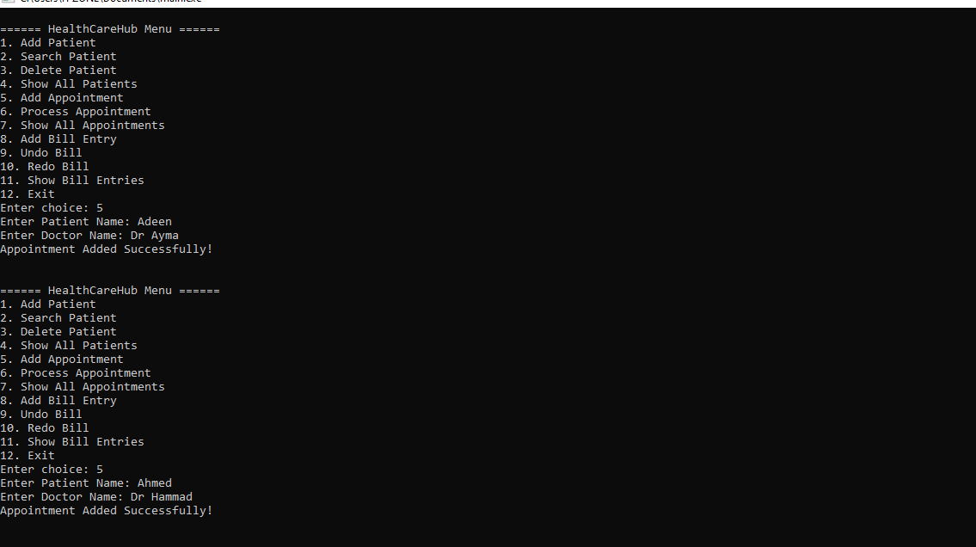
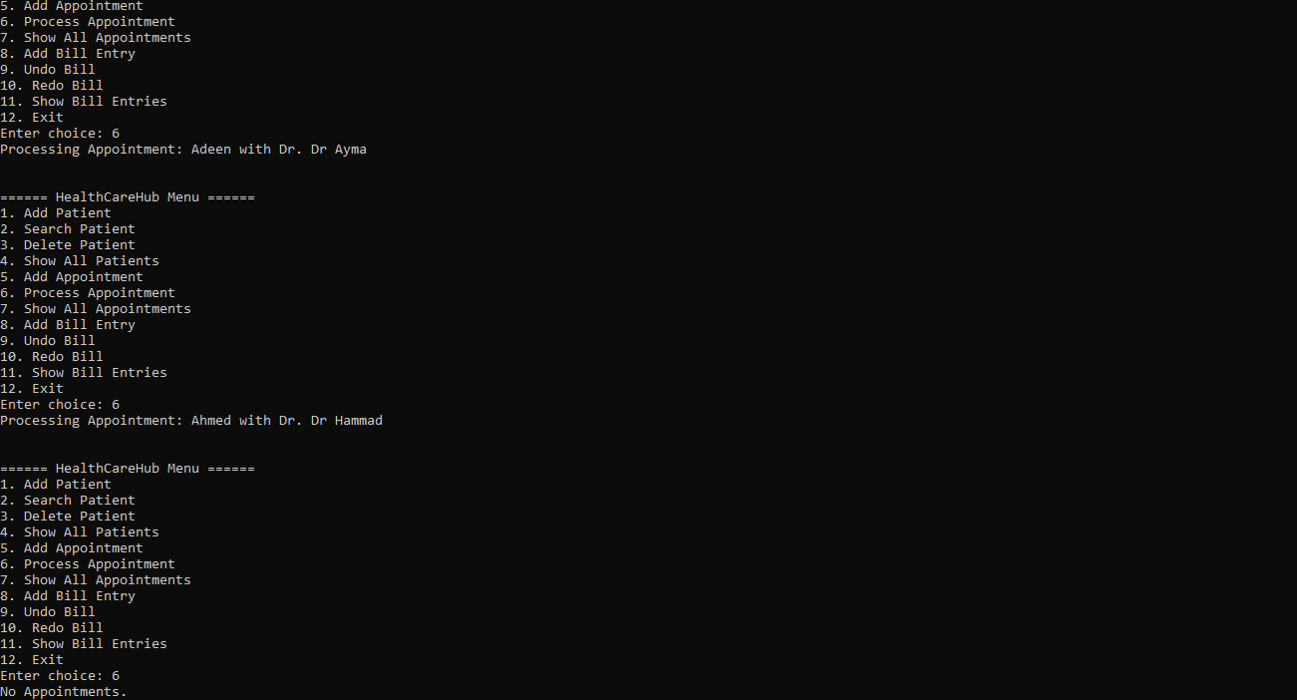

- BILL ENTRY – STACK UNDO/REDO – TEST CASES
✔ Normal Inputs
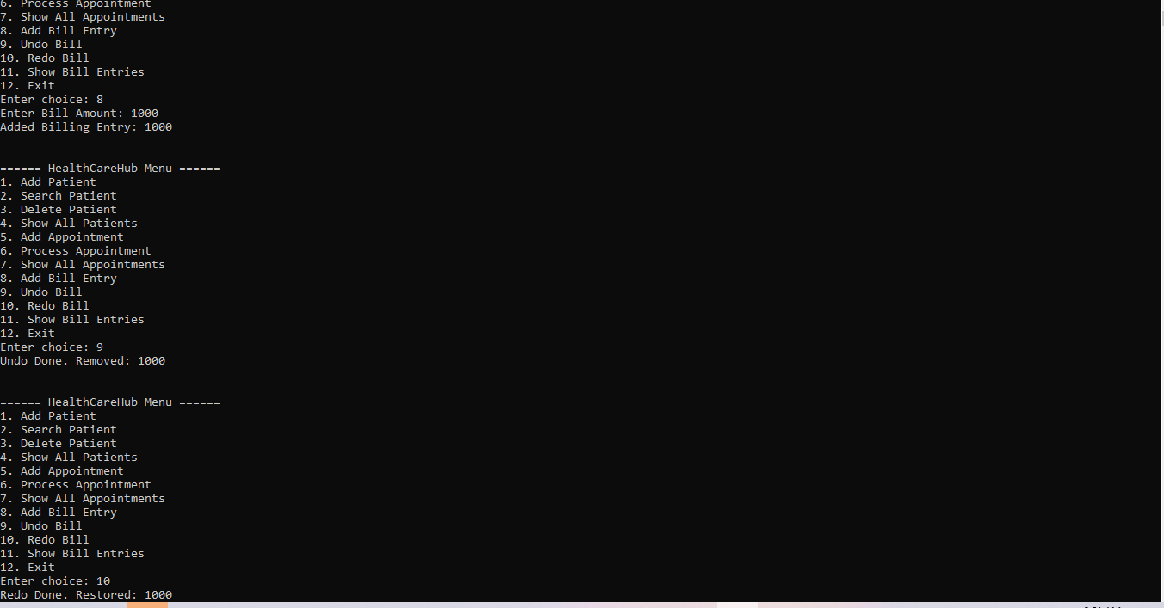
❌ Incorrect Inputs
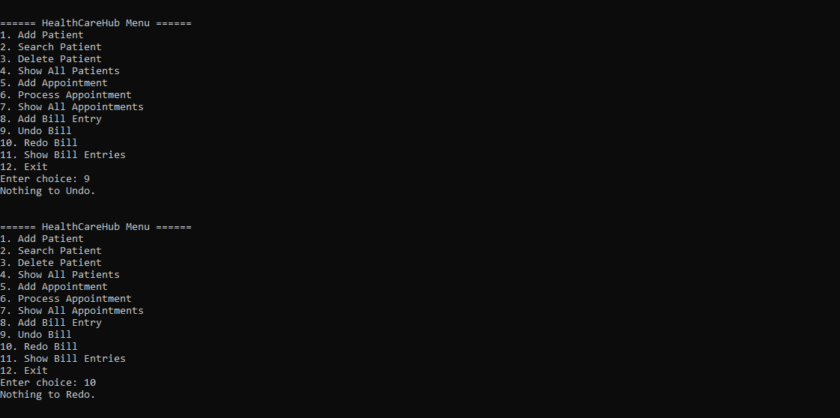
⚠ Edge Cases
